Need to replace with user

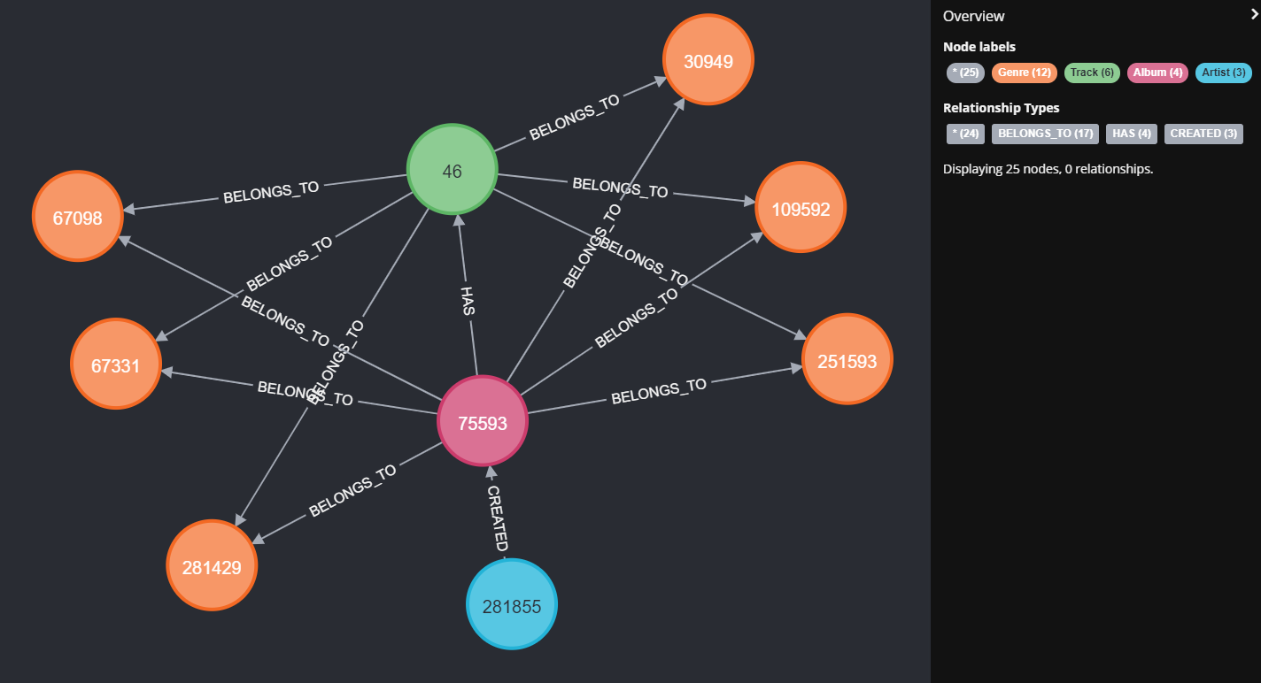

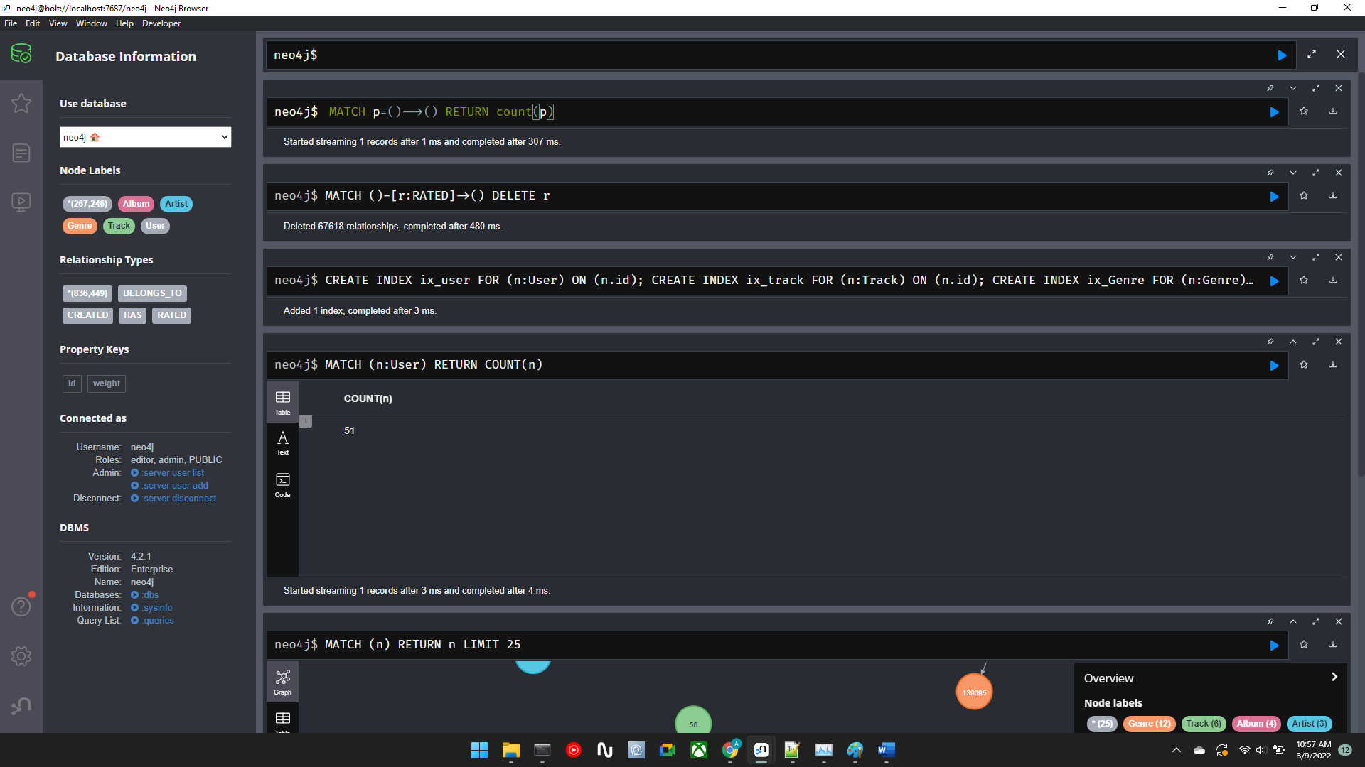

Sample status

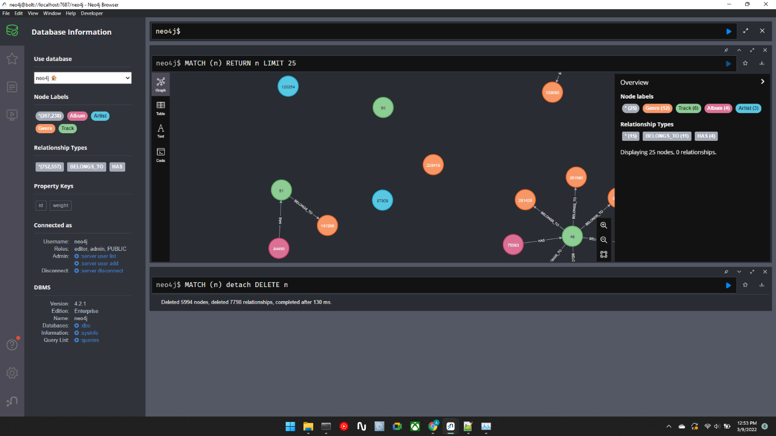

Created graph

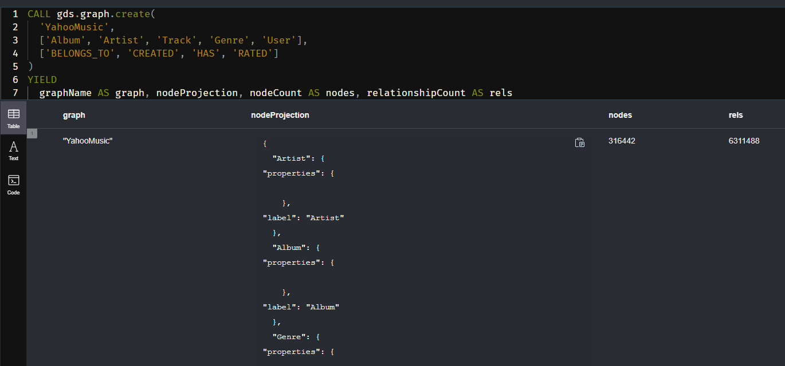

Compute cost close_query.csv (distance between directly connected nodes)

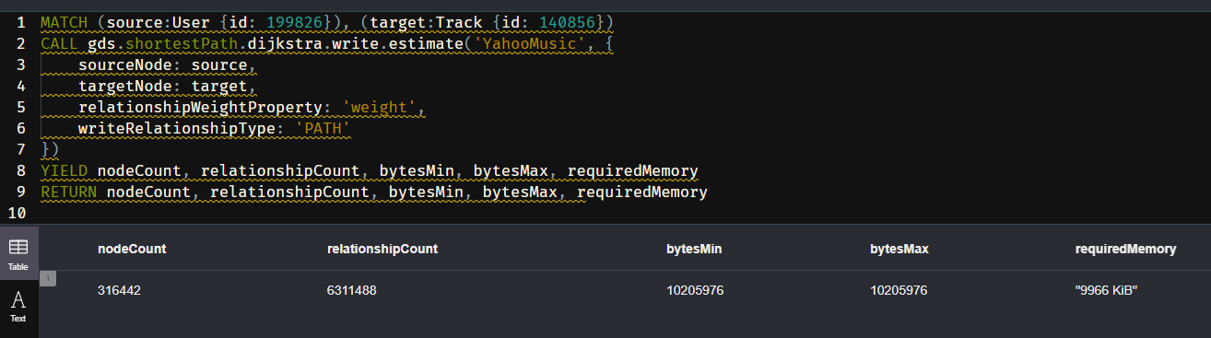

Compute cost of path length of 5 from user to track long_query.csv

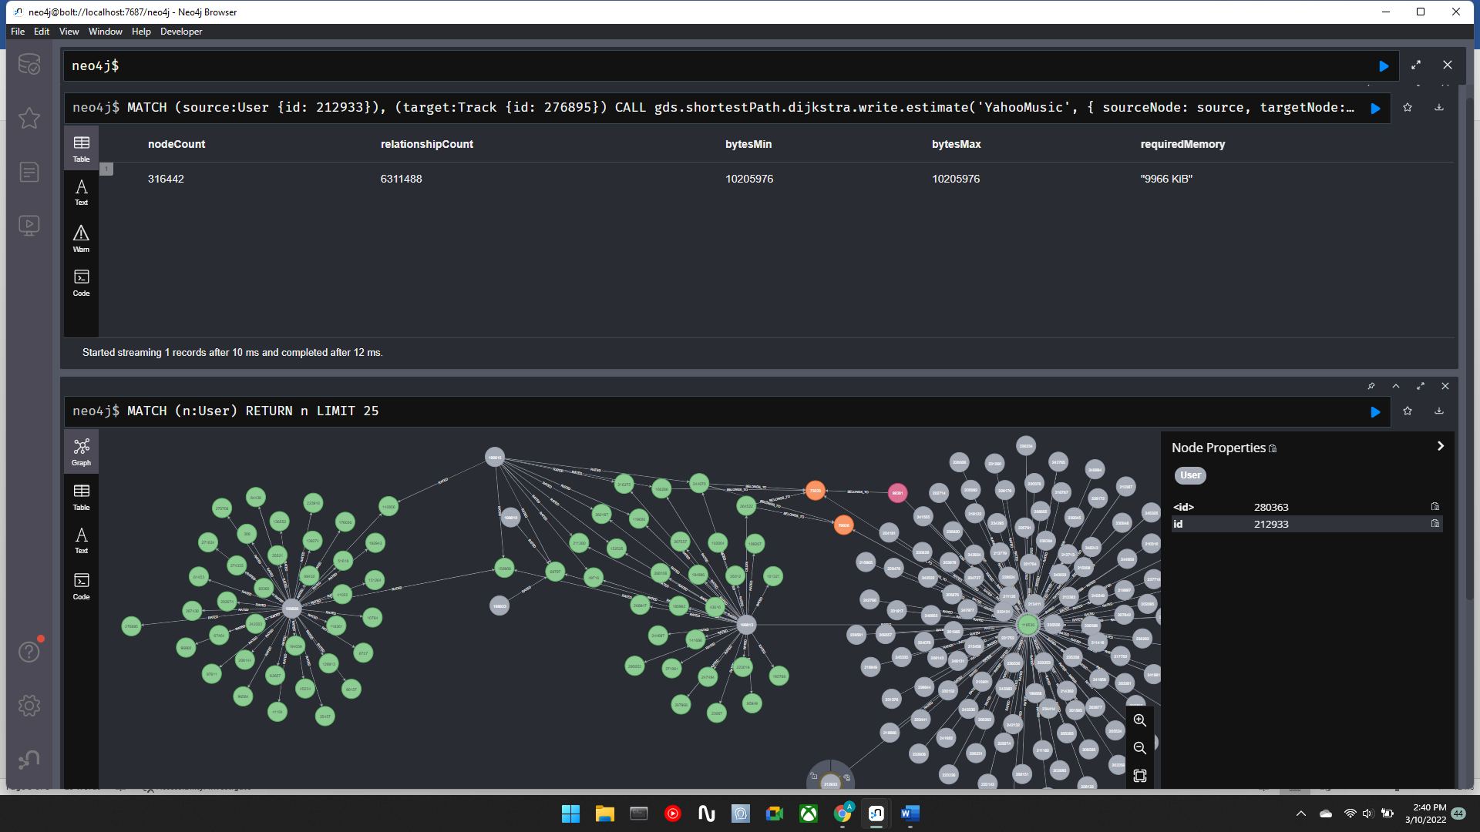

*Yen’s Shortest Path algorithm*

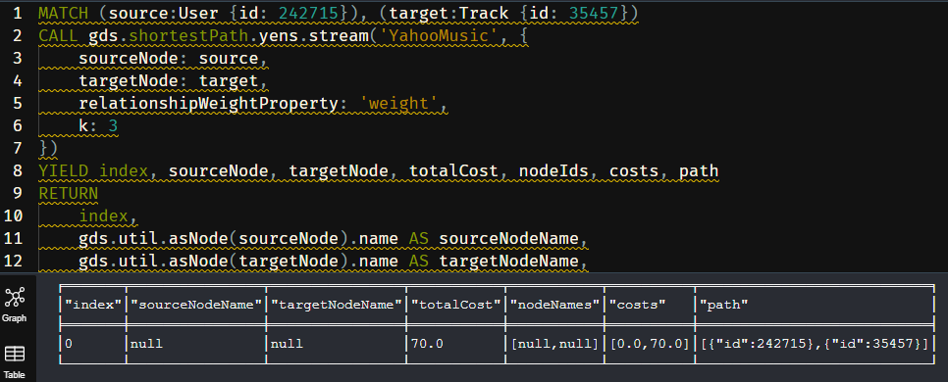

│"index"│"sourceNodeName"│"targetNodeName"│"totalCost"│"nodeNames"│"costs" │"path" │

╞═══════╪════════════════╪════════════════╪═══════════╪═══════════╪══════════╪════════════════════════════╡

│0 │null │null │70.0 │[null,null]│[0.0,70.0]│[{"id":242715},{"id":35457}]│

nodeSimilarity.csv

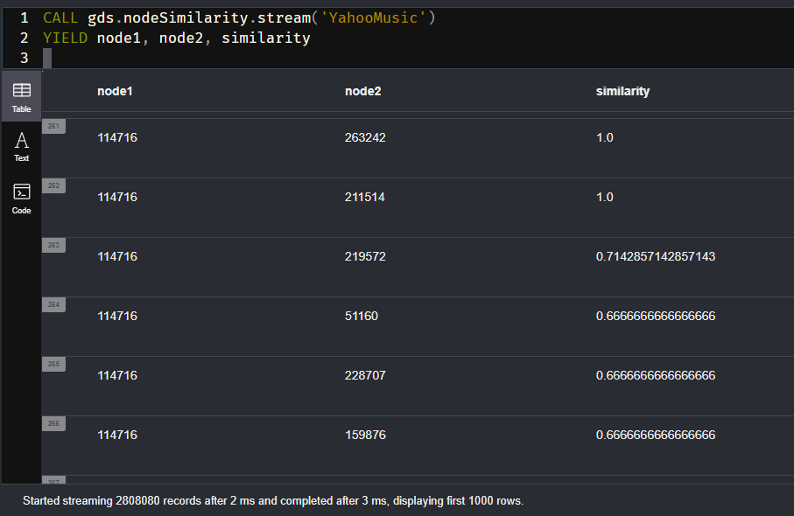

Jaccard.csv

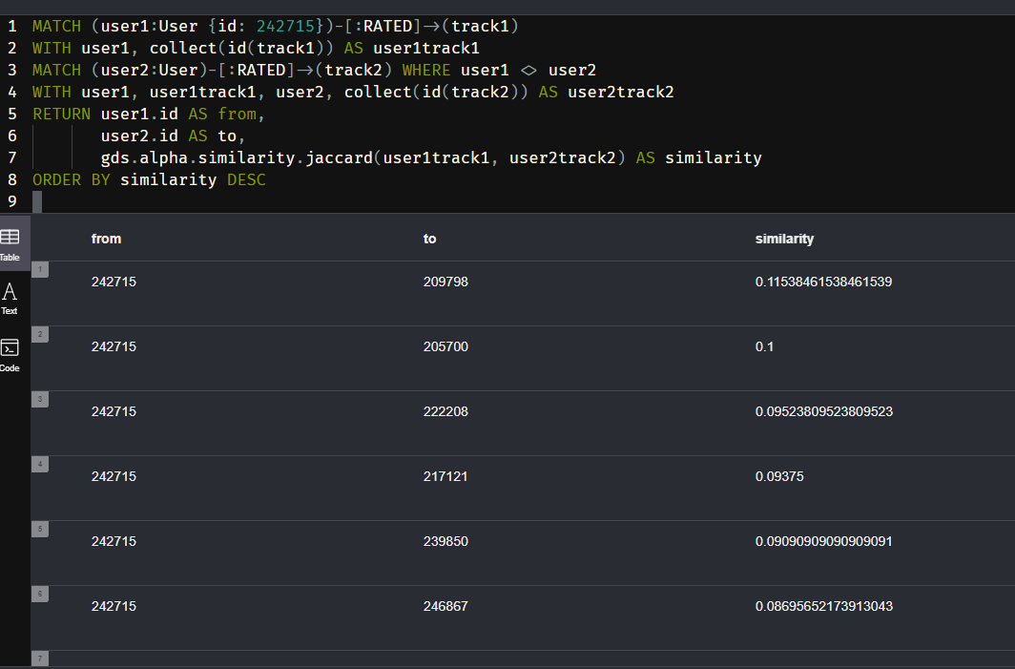

yahooMusic-Neo4j.py is doing a lot of work but not writing anything out. After 8hrs of running imap_unordered should complete tasks in any order

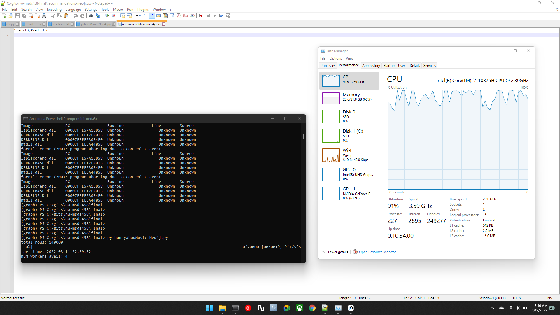

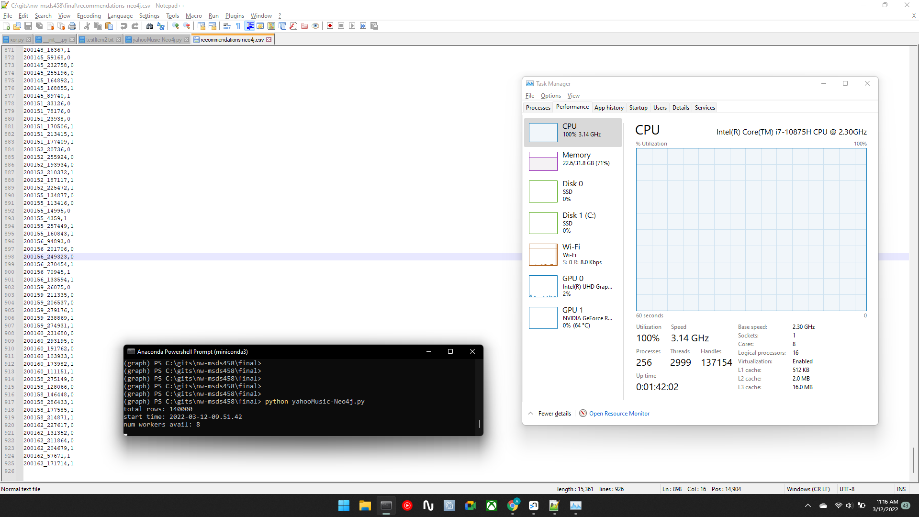

**1000songs/90min = 10songs/min,**

**120,000 songs/10 = 12,000 min = 200hours > 8days**